**NATIONAL INSTITUTE OF TECHNOLOGY**

**KURUKSHETRA**



**PRACTICAL FILE**

**SUBJECT :-** **Programming Using Python**

**BRANCH :- CS-A-01**

**ROLL NO :- 12112003**

**Submitted to:-**

**Shweta Pandey mam**

**Submitted by:-**

**Priyanshu maurya**

**Experiment-6**

1. Write a Python program to read an entire text file.

file = open('file.txt', 'r')

content=file.read()

print(content)

file.close()

OUTPUT

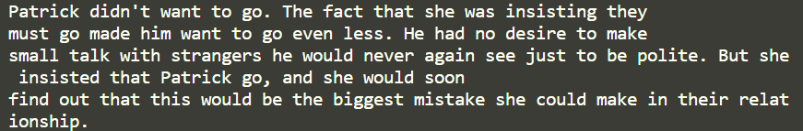

1. Write a Python program to read a file line by line and store it into a list.

file = open('file.txt', 'r')

*# list = file.readlines()*

*# print(list)*

*list* = []

for a in file:

*list*.append(a)

print(*list*)

file.close()

OUTPUT

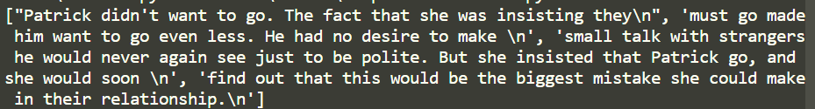

1. Write a Python program to combine each line from first file with the corresponding line in second file.

file1 = open('first.txt', 'r')

file2 = open('second.txt', 'r')

for a, b in zip(file1, file2):

    print(a.replace('\n', ''), b.replace('\n', ''))

file1.close()

file2.close()

OUTPUT 

1. Write a Python program that takes a text file as input and returns the number of words of a given text file.

file = open('file.txt', 'r')

*dict* = {}

for a in file:

    for i in a.split(" "):

        dict[i.replace('\n', '')] = 1

print(len(*dict*))

OUTPUT



1. Write a Python program to generate 26 text files named A.txt, B.txt, and so on up to Z.txt.

for i in range(65,91):

*str*=chr(i)+'.txt'

*# print(str)*

    file=open(*str*,'w+')

1. Write a Python program to create a file where all letters of English alphabet are listed by specified number of letters on each line.

n=*int*(input("Enter no of characters in each line: "))

file=open('file1.txt','w+')

c=0

for i in range(65,91):

    file.write(chr(i))

    c+=1

    if c%n==0:

        file.write('\n')

OUTPUT

